Title: CPOC-2017 radiosonde data

Authors:

Matthew Brewer (mjbrewer@albany.edu)¹
Justin R. Minder (jminder@albany.edu, ORCID: 0000-0001-7182-7898)¹*

^{1.} Department of Atmospheric and Environmental Sciences, University at Albany, Albany, NY, USA
*Corresponding author address:
Department of Atmospheric and Environmental Sciences, University at Albany, 1400 Washington Ave, Albany, NY 12222. Email: jminder@albany.edu

1.0 Data Set Overview:

This dataset contains data from radiosondes launched during Chemical Processing of Organics within Clouds (CPOC) 2017 pilot study. All soundings were launched from the Northwood School (NWS) in Lake Placid New York. NWS is located roughly 10km SSW of the summit of Whiteface Mountain(WFM). The location of the NWS is provided in Table 1 and Figure 1 below.

Time period covered: 11 August 2017 – 25 August 2017

Table 1: Summary of location of radiosonde launches
Abbreviated name | Full name | Latitude  [deg.] | Longitude  [deg.] | Elevation [m, MSL] | Observation period
NWS | Northwood School | 43.291 | -73.971 | 583 | 11 August 2017 – 25 August 2017

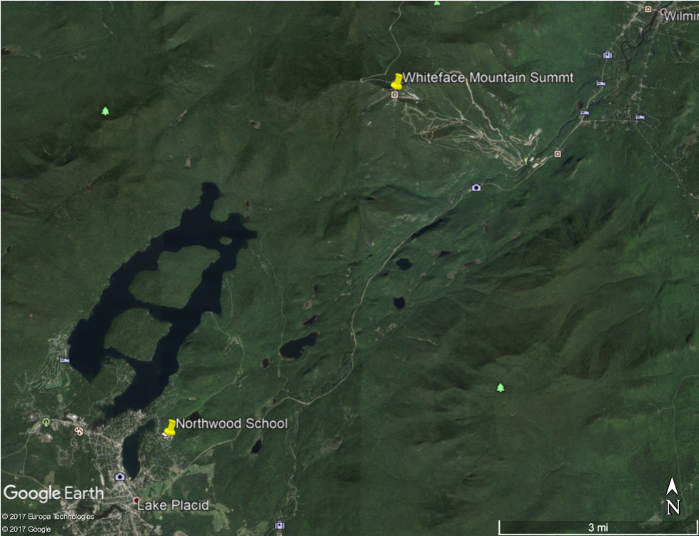
Figure 1: Locations of Northwood School (NWS) sounding launch location and the summit of WFM.

Sondes were launched during CPOC intensive observing periods (IOPs), focusing on events where the summit of WFM was in cloud with no precipitation. During the 2 week field campaign we had 7 days of interest. 18 sondes were launched during the 7 IOPs. A listing of IOPs and launch times is provided in Table 2.

Table 2: IOP #, launch site, and launch time for CCOPE soundings
IOP # | Launch site | UTC launch time (yyyy-mm-dd_HHMM)
1 | NWS | 2017-08-13_1358
1 | NWS | 2017-08-13_1502
2 | NWS | 2017-08-15_1231
2 | NWS | 2017-08-15_1429
2 | NWS | 2017-08-15_1553
3 | NWS | 2017-08-18_1338
3 | NWS | 2017-08-18_1527
3 | NWS | 2017-08-18_1734
4 | NWS | 2017-08-19_1210
4 | NWS | 2017-08-19_1403
4 | NWS | 2017-08-19_1608
4 | NWS | 2017-08-19_1836
4 | NWS | 2017-08-19_2007
5 | NWS | 2017-08-20_1320
5 | NWS | 2017-08-20_1505
6 | NWS | 2017-08-22_1928
7 | NWS | 2017-08-23_1318
7 | NWS | 2017-08-23_1507

2.0 Instrument Description:

All soundings are InterMet iMet-1 Balloon Radiosondes (http://www.intermetsystems.com/products/imet-1) using a iMet-3150 403MHz GPS ground system (http://www.intermetsystems.com/products/imet-3150) and the iMetOS-II software (InterMet, 2014). The attributes of the sensors on the iMet-1 radiosonde are summarized in Table 3.

Table 3: Sensor attributes for iMet-1 radiosonde (based on: http://www.intermetsystems.com/ee/pdf/202060_iMet-1-ABxn_Data_161006.pdf)
Pressure
Type | Piezoresistive
Range | 2 to 1070 hPa
Accuracy | 0.5 hPa
Resolution | < 0.01 hPa
Response Time | < 1.0 Sec
Temperature
Type | Bead Thermistor
Range | -95 to +50 deg. C
Accuracy | 0.2 deg. C
Resolution | < 0.01 deg. C
Response Time | 2.0 sec @ 1000hPa
Humidity
Type | Capacitive
Range | 0 to 100% RH
Accuracy | 5% RH
Resolution | < 0.1% RH
Response Time | 2 sec @ 25 deg. C; 60 sec @ -35 deg. C
GPS
Type | C/A code, 12 Channel
Tracking | Continuous
Update Rate | 1 Hz
Position accuracy | 10 m
Wind velocity accuracy | 1.0 m/s
Altitude accuracy | 15 m

3.0 Data Collection and Processing:

All launches used 100 g balloons. Data was collected until loss of radio signal.
Data were collected at 1Hz sampling rate. Raw data were post-processed using interMet’s iMetOS-I (InterMet, 2015) default processing. No other post-processing was applied.

4.0 Data Format:

The raw data files are named with the following format:

iMetSounding_NWS_YYYYMMDD_HHMMUTC

Text files used to plot sounding as well as create other plot are named with the following format:
iMetSounding_NWS_YYYYMMDD_HHMMUTC_reform.txt

Data files are in fixed-width ASCII text. The first three lines are a header that label the names and units of the columns of data. The columns correspond to the following:

Variable | Abbreviated name in header | Units
Date | UTC_Date | UTC (d/m/yyyy)
Time | UTC_Time | UTC +4 hours (HH:MM:SS AM/PM)
Time since launch | Time | Seconds
Longitude | Long/E | Degrees-East
Latitude | Lat/N | Degrees-North
Altitude above sea level | Alt_MSL | Meters
Geopotential height above ground level | GPM_AGL | Meters
Pressure | Press | hPa
Temperature | Temp | Degrees Celsius
Dew point | DP | Degrees Celsius
Relative Humidity | RelHum | Percentage
Wind speed | WSpeed | m/s
Wind direction | WDirn | Degrees

5.0 Data Remarks:

Several soundings experienced loss of signal at low range, sometimes due to problems with the radio receiver. As a result soundings from IOPs 4 and 5, only collected data through the lower-to-mid troposphere. Soundings on IOP 1 had issues with radio signal loss however signal was recovered. Data between the loss in signal and recover yields unrealistic lapse rates and extremely high winds.
The UTC Time in the data is off by plus 4 hours from actual UTC time. The UTC time in the file name is the correct UTC time corresponding to the time of launch.

6.0 References:

InterMet, 2014: Software reference manual for the iMetOS-II Meteorological Operating Software, Document No. 200,850, Revision 3.34.0.

